Summer 2007: Chennai, India

80% of blindness is preventable. Preventable blindness affects over 36 million people in the world. The degeneration of something as natural and spectacular as eyesight is terrible, and yet it often goes ignored by those who do not have access to a doctor or have money to receive treatment. This summer, I volunteered for Unite For Sight and its partner clinic, Uma Eye Clinic, in India’s third largest city, Chennai, working to bring treatment, to bring medical attention, and to bring back the beautiful gift of eyesight to those in need.

These unfortunate people often live in village huts on the outskirts of the city or in the overcrowded, chaotic slums within the city. It was to these places that we would visit during the week, sometimes a two-hour van ride away. The sights were incredible—huts with straw roofs, cows in the middle of streets, piles of garbage by the side of the roads, colorful saris hung out to dry. The sounds ranged from loud music and blaring car horns in the city to the peaceful sounds of nature in the villages.

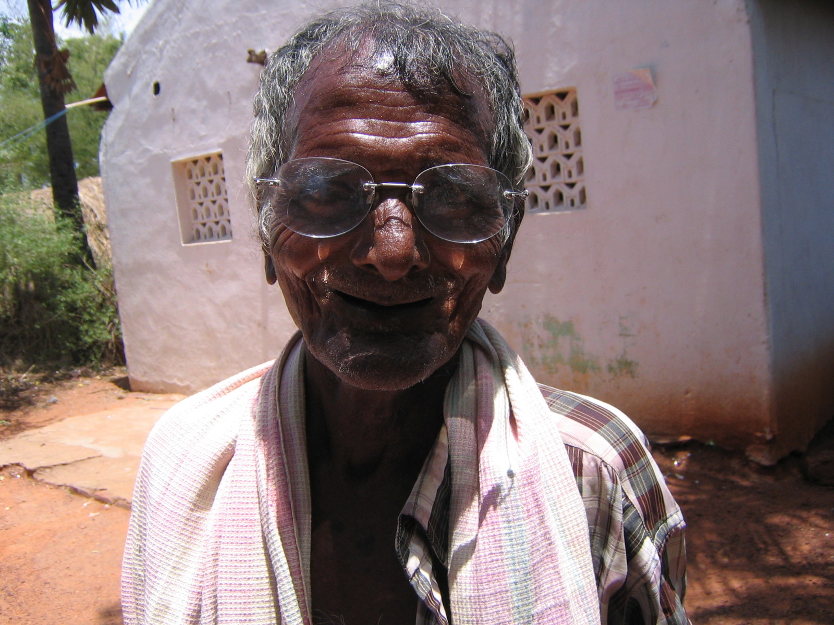
We worked in one-room churches, under canopies in the open air, and even from inside our transportation van, once, handing out glasses through the windows because it was too crazy outside of the van. Our main tool, a simple flashlight used to see advanced cataracts, was primitive compared to the technology I had witnessed while shadowing ophthalmologists in Princeton. Despite differences in work rooms and tools, the care provided was still very similar. We tested for the patients’ visual acuity, much like nurse technicians, before sending them to the optometrist to get a precise “prescription,” then the ophthalmologist, with us alongside, checked the patients for cataracts. Finally, we filled their “prescriptions” by providing them with a pair of free eyeglasses. Those with cataracts drove back with us for free cataract surgery at the clinic; sometimes we would see them the next day during post-operative check ups. After camp, the villagers would serve us a delicious lunch on banana leaves.

Old women, who had been unable to see my fingers distinctly a mere three meters away, were coming out of cataract surgery seeing nearly 20/20 the next day at the post-operative check-up. It was always incredible to see them waving their arms excitedly while describing the new colors and the fresh sights. But I realized even something as small as handing a middle-aged man a pair of reading glasses and asking if he could see the letters was significant. A simple, bright smile and a heart-felt handshake of gratitude was empowering; even at times of frustration with the chaotic pushing and yelling of women trying to be first in line (if there was a line), one person’s smile or hearty handshake would make everything alright. I hoped, in going to India, that I could help change lives individual by individual, and I’ve realized that the villagers were able to show me the power of a single person, a single gesture. They’ve also shown me how to appreciate the little things. Even living in a slum or a tiny, rural village in a third world country, these people were happy and had a real sense of community and care for each other. It was incredibly fun to be a part of that.
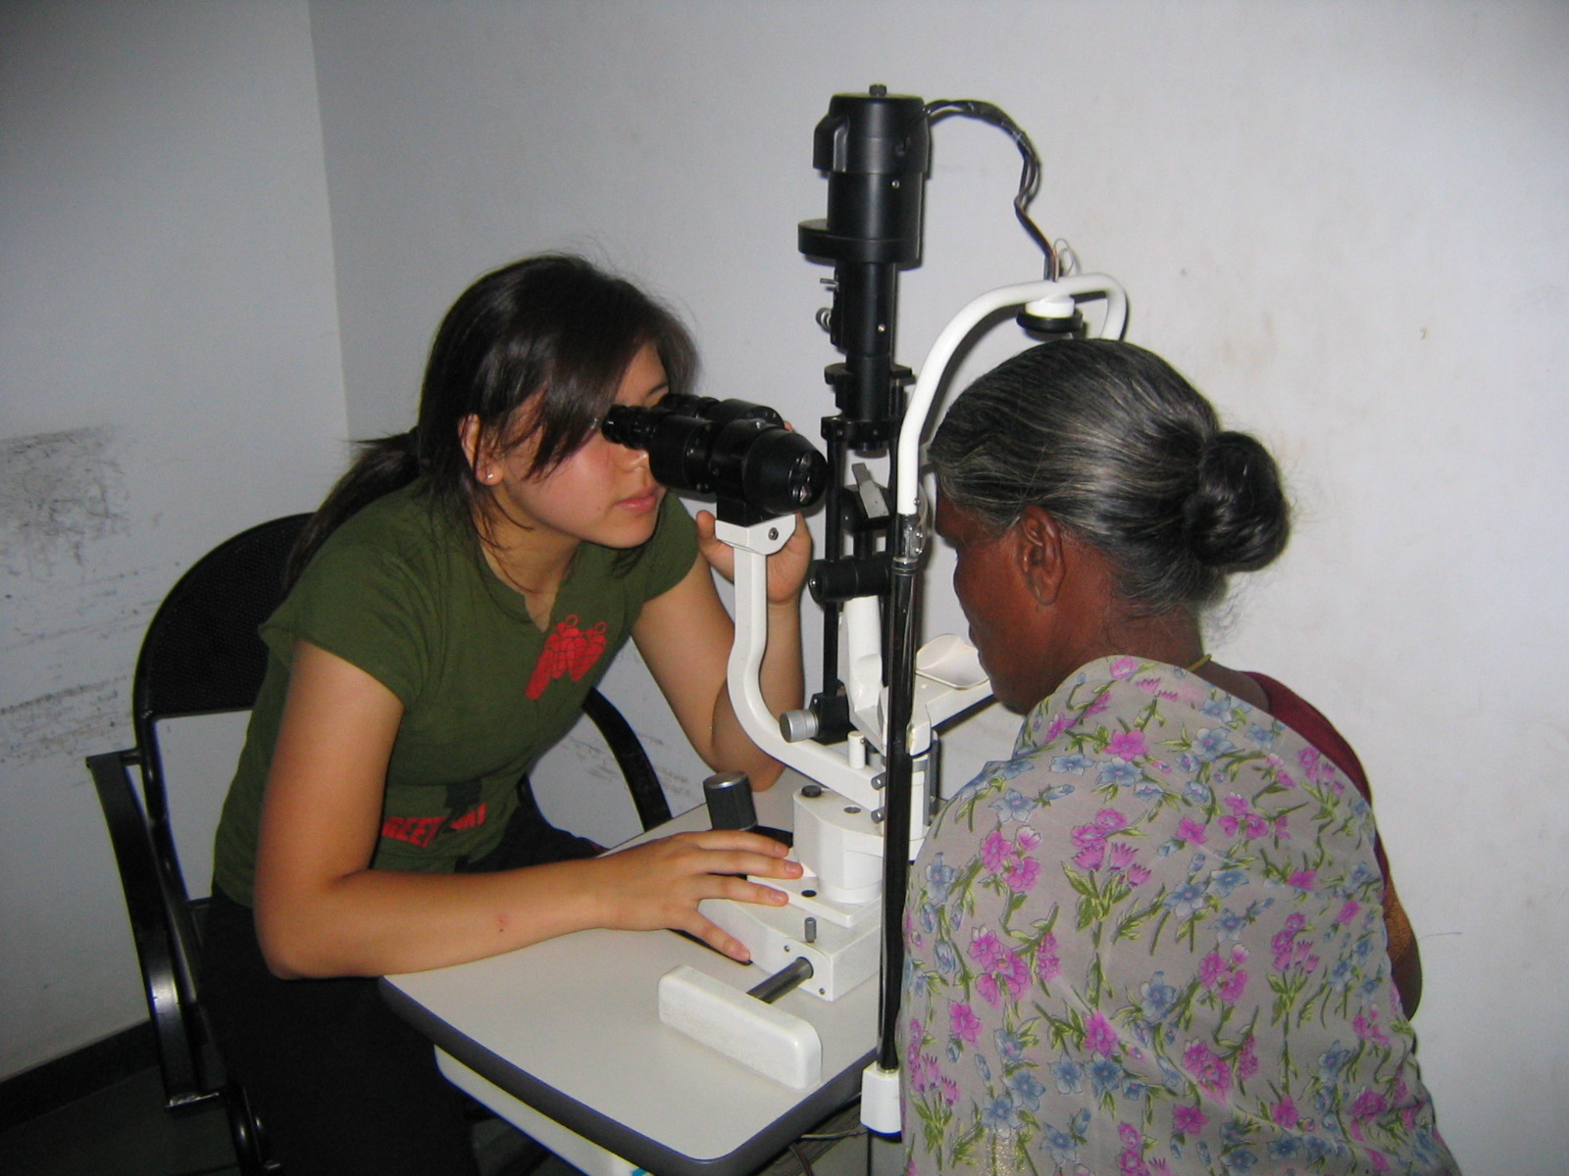
We saw old men and women, their skin wrinkled from decades in the sun, and we saw young schoolchildren, energetic and pleased to practice their bits of English. Unfortunately, we saw elderly people, whose pupils were opaque with cataract, scared to go through the surgery, and we saw Indians, who had lost their vision in an eye entirely because of previous surgeries that had gone wrong. We learned how to count and how to say “close one eye” and “can you read this?” in the local language, Tamil. Still, language was a significant barrier between us, and sometimes it was frustrating to be unable to communicate certain things such as “these glasses are for reading only” or how safe and beneficial cataract surgery is to those who were scared. However, goodwill is a universal gesture, and India has made me a firm believer of that—thanks to the patients, the doctors I worked with, and my fellow volunteers. In the future, I believe that things will continue to improve, and my experience this summer, which has been extraordinary and fulfilling, has shown me that I want to be a part of that future.

-- Vicki Chen

Without the generous support and encouragement of many people, this amazing trip would not have been possible. I want to thank the following people from the bottom of my heart:, Clare Ralston, Chungte and Jenna Chen, Julia Chen, The Bent Spoon, Mehek, Tomo Sushi, Istvan Pelczer, and particularly, the Class of 1978 Foundation.

